# Evaluation of the Existing Systems

1. Site investigations and visual inspection by the PMC design team.

The existing water pipelines captured during the site visits.



#### Site Visits Photos for Existing Water Pipes Z X

# STRUCTURAL CONDITIONAL ASSESSMENT OF WDS

### Choolaimedu WDS

|  |  |
| --- | --- |
| Pumping station | Ground Level Reservoir |
| Pump Room | Diagonal Crack (Inner Surface of Room) |
| Diagonal Crack above Corbel (Inside) | Diagonal Crack above Corbel (Outside) |
| Water stagnant on Chlorine Room Terrace | Damp Patches on Chlorine Room Ceiling |
|  |  |
| Cracks at Various Places in Pumping Stations | |
| MS Staircase corroded and damaged | Damaged MS Platform |

### K.K. Nagar new WDS

Photographs:

|  |  |
| --- | --- |
| A picture containing grass, outdoor, sky, building  Description automatically generated  Pumping Station | A picture containing grass, outdoor, sky, building  Description automatically generated  Overhead Tank |
| A picture containing indoor, ceiling  Description automatically generated  Pump Room | A picture containing tree, outdoor, grass, sky  Description automatically generated  Chlorine tonners stacked in open area |

### K.K Nagar Old WDS

|  |  |
| --- | --- |
| **  Chlorine Building | ****  Overhead Tank |

### Valluvarkottam Headworks WDS

Photographs:

|  |  |
| --- | --- |
| **  Ground Level Reservoir | A picture containing tree, outdoor  Description automatically generatedOverhead Tank |

### Southern Headworks WDS

|  |  |
| --- | --- |
| A group of people walking out of a building  Description automatically generated with medium confidence  Pumping Station  A picture containing floor, building, indoor, furniture  Description automatically generated  Chlorine Room | A picture containing text, indoor, scene, library  Description automatically generated  Pump Room  A picture containing indoor  Description automatically generated  Chlorine Room Roof |
| A picture containing outdoor, building, colonnade  Description automatically generated  Overhead tank    Damaged OHT Bottom Slab | A picture containing tower  Description automatically generated  Damaged Staircase  A picture containing old  Description automatically generated  OHT Bottom Slab |

# SOCIAL SAFEGAURD SITUATION REVIEW & IMPACT ANALYSIS

## Ground Situations of Water Supply and Its Satisfaction

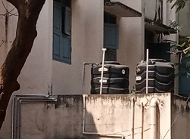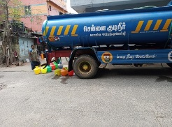

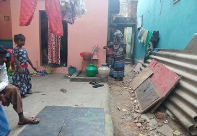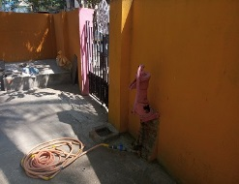

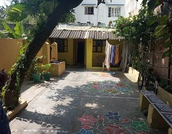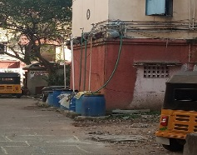

#### Multiple Sources to Access Potable Water

# ELECTRICAL CONDITIONAL ASSESSMENT

**Choolaimedu WDS:**

|  |  |
| --- | --- |
| IMG_20210911_112237  2 x 4 MVA Power Transformer | A picture containing indoor, yellow  Description automatically generated  2 MVA, 3.3 kV DG SET |
| IMG_20210911_112406  200 kVA AUX. TRANSFORMER | A picture containing indoor, cabinet, dirty  Description automatically generated  11 kV PANEL |
| IMG_20210911_111748  11 kV Switchboard | IMG_20210911_111948  3.3 kV Switchboard |
| IMG_20210911_112040  ATS Starter | IMG_20210911_111859  ATS Starter Panel |
| IMG_20210911_112613  3.3 kV PANEL | IMG_20210911_112650  LV SWITCHBOARD |
| IMG_20210911_113236  LPBS & MOV Starter | IMG_20210911_113240  MOV |
| IMG_20210911_113323  3.3 kV/ 500 KW | IMG_20210911_113425  LDBs & JBs |

**K.K. Nagar- New Head Works:**

|  |  |
| --- | --- |
| A picture containing text, indoor  Description automatically generated  FCMA Soft Starter Panel | Diagram  Description automatically generatedLV Distribution Panel |
| A picture containing text, indoor, vending machine  Description automatically generated  11 kV Switchboard | A picture containing text  Description automatically generated  450 kVAR APFCR Panel |
| A picture containing indoor, ceiling  Description automatically generated  1010 kVA DG Set | A picture containing indoor, floor, ceiling, area  Description automatically generated250 kW VT Motors |

**K.K. Nagar- Old WDS:**

|  |  |
| --- | --- |
| A picture containing floor, indoor, device, miller  Description automatically generated  11 kV Switchgears Panel | A picture containing wall, indoor, dirty  Description automatically generated  Inside Pump House- Pump Motor Set |
| A refrigerator with magnets on it  Description automatically generated with medium confidence  55 kW Star-Delta Starter | A picture containing indoor, room, old, furniture  Description automatically generatedOutside Pump House- Pump Motor |
| A picture containing indoor, device, dirty  Description automatically generated  Chlorine Gas Blower | DG Set |

**Valluvarkottam WDS:**

|  |  |
| --- | --- |
| A picture containing dirty  Description automatically generated  3.3 kV/ 300 kW Motor | A picture containing text, indoor, miller  Description automatically generated  3 MVA Transformer |
| IMG_20210911_124130  11 kV VCB Switch Board | IMG_20210911_124146  3.3 kV VCB Switchboard |
| IMG_20210911_124421  3.3 kV Auto-transformer Starter (ATS) Panel | IMG_20210911_124233  3.3 kV Capacitor Banks |
| A picture containing indoor, cluttered, miller  Description automatically generated  MOV with external Starter Unit | A picture containing indoor  Description automatically generated  Chlorine Gas blower & LDBs |
| A picture containing device, tool, miller  Description automatically generated  DBs & Corroded Earthing | IMG_20210911_124240  LV Switchboard |

**Southern Headworks**

|  |  |
| --- | --- |
| A picture containing floor, indoor, gate, furniture  Description automatically generated  1250 kVA transformer | A picture containing indoor, furniture, old, decorated  Description automatically generated  11 kV Switch Board |
| A picture containing cabinet, furniture  Description automatically generated  LV Switchboard | Calendar  Description automatically generated  APFC Panel |
| A picture containing floor, indoor  Description automatically generated  Old Capacitor Banks | Text  Description automatically generated with medium confidenceNew VFD Starter Panel |
| IMG_20210911_153607  LV Motor & MOV | A picture containing text  Description automatically generated  LDBs |
| IMG_20210911_160116 | IMG_20210911_160135 |
| DG Set | |

# INSTRUMENTATION & CONTROL CONDITIONAL ASSESSMENT

## K.K. Nagar Old WDS

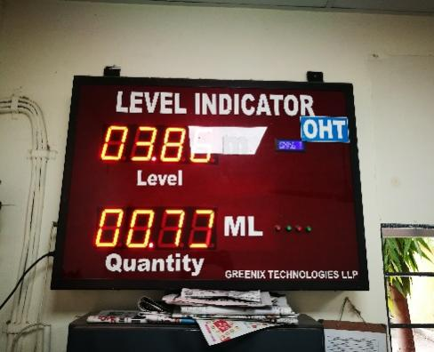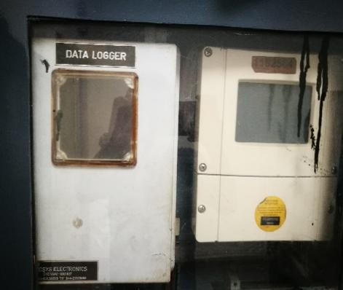 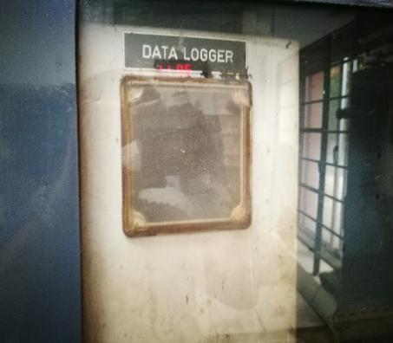

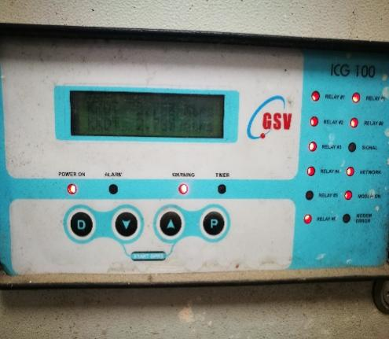 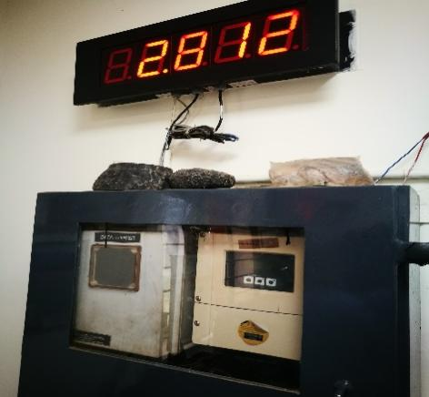 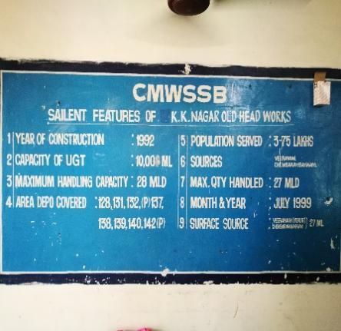

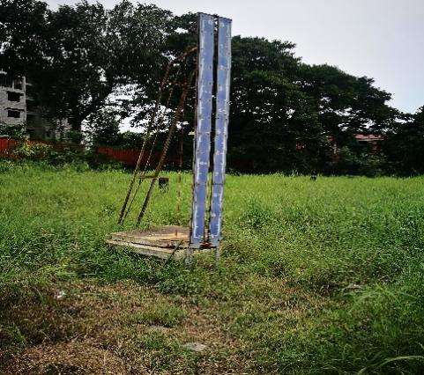 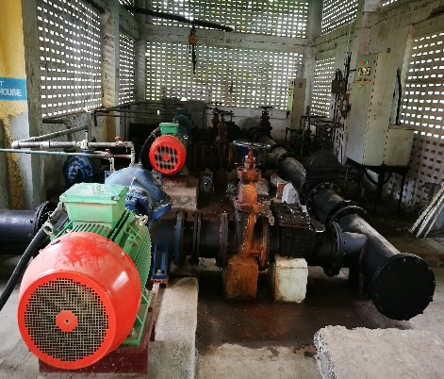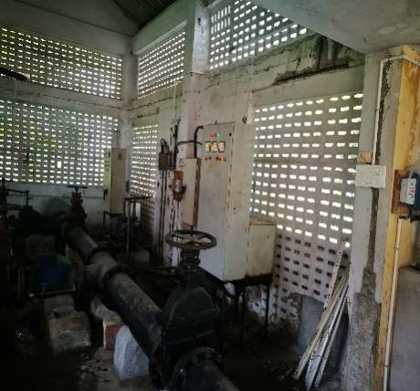

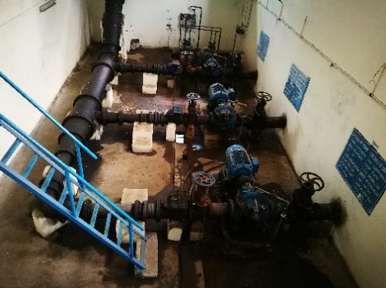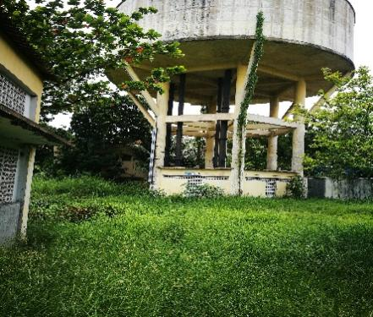 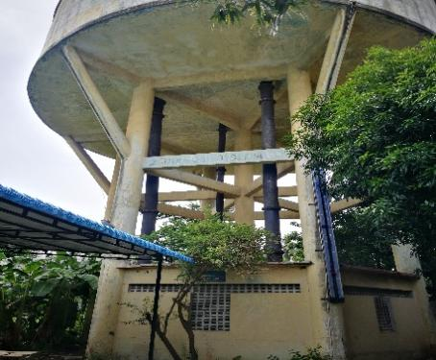

## K.K. Nagar New

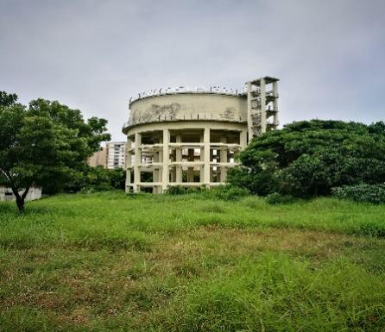 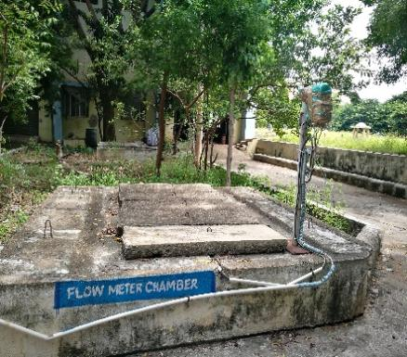 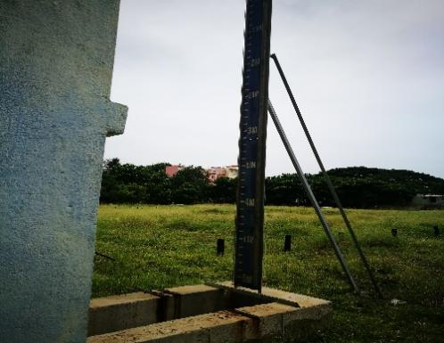

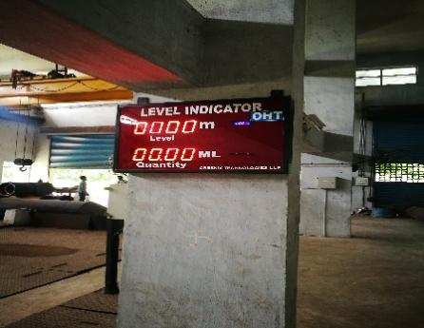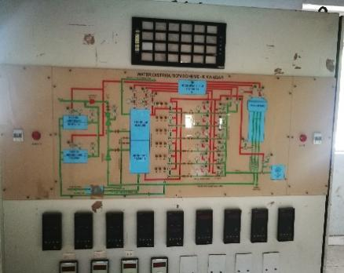 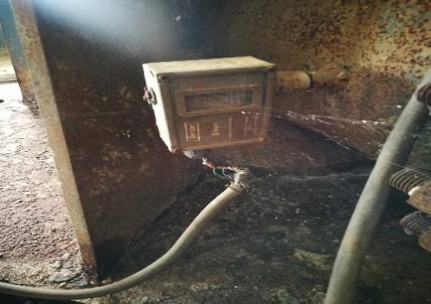

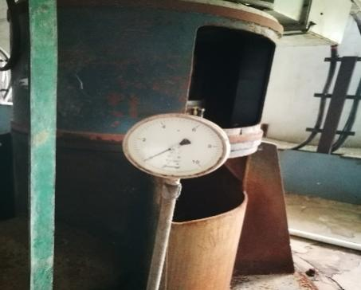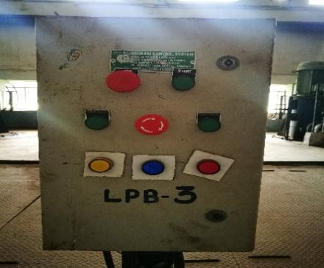 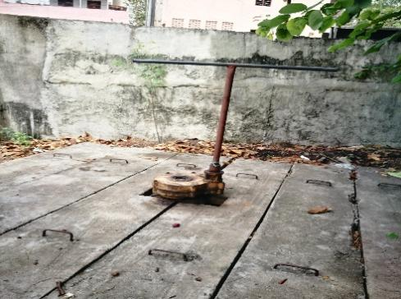

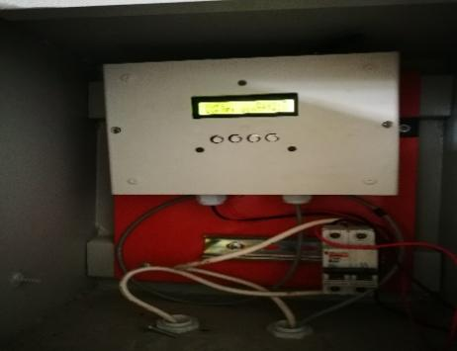 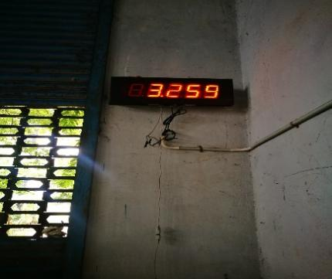 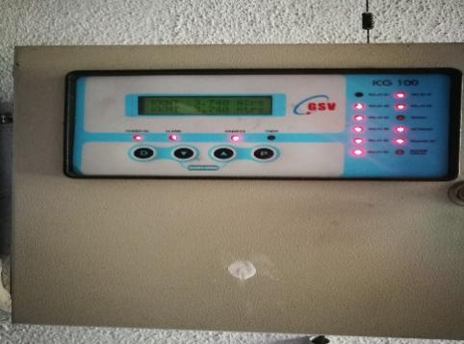

## Choolaimedu WDS

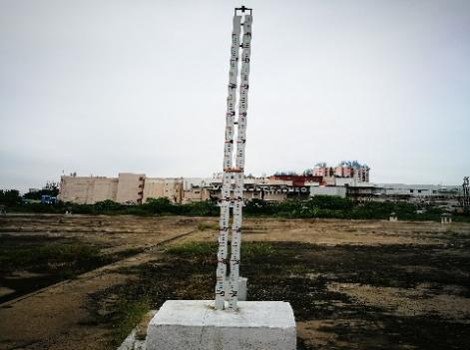 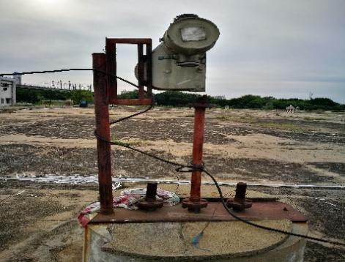 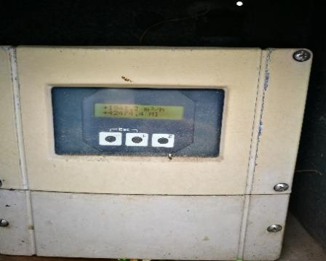

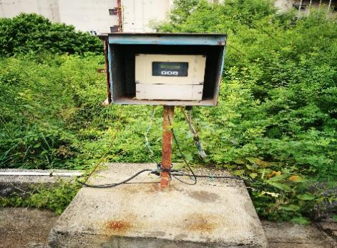 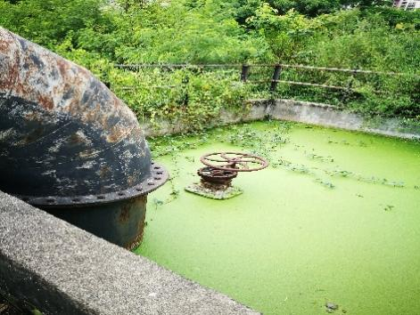 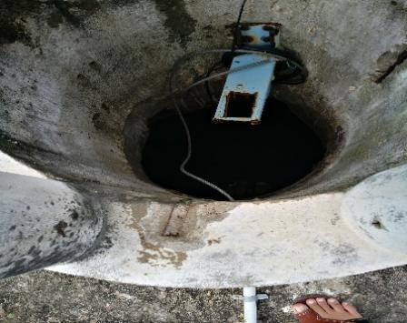

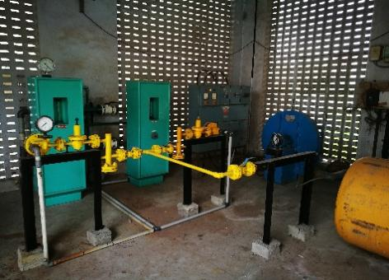 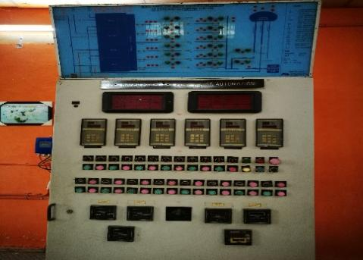 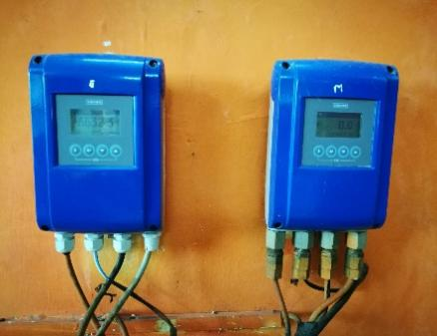

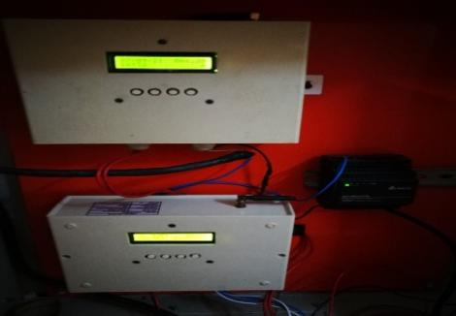 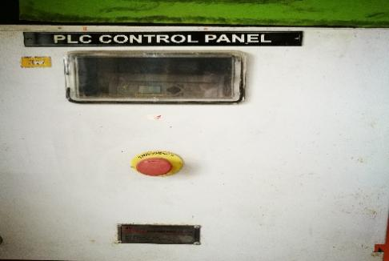 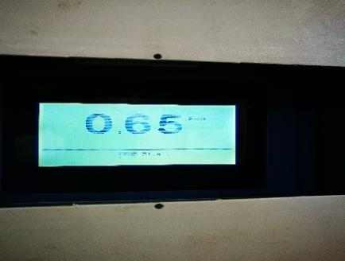

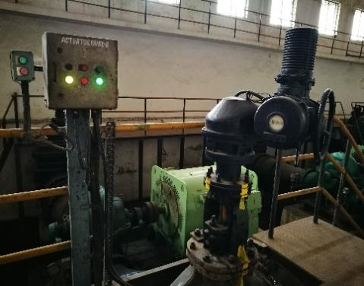 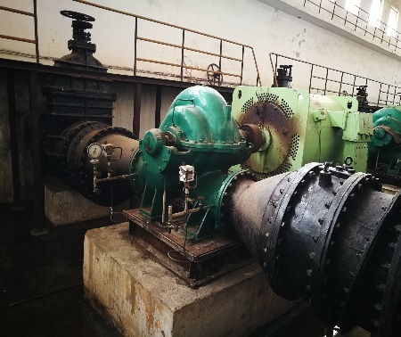 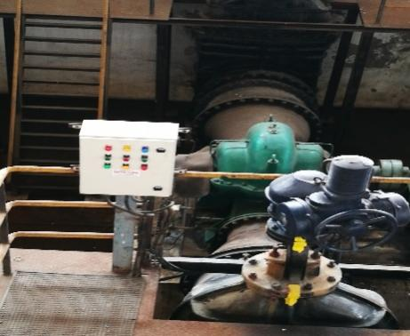

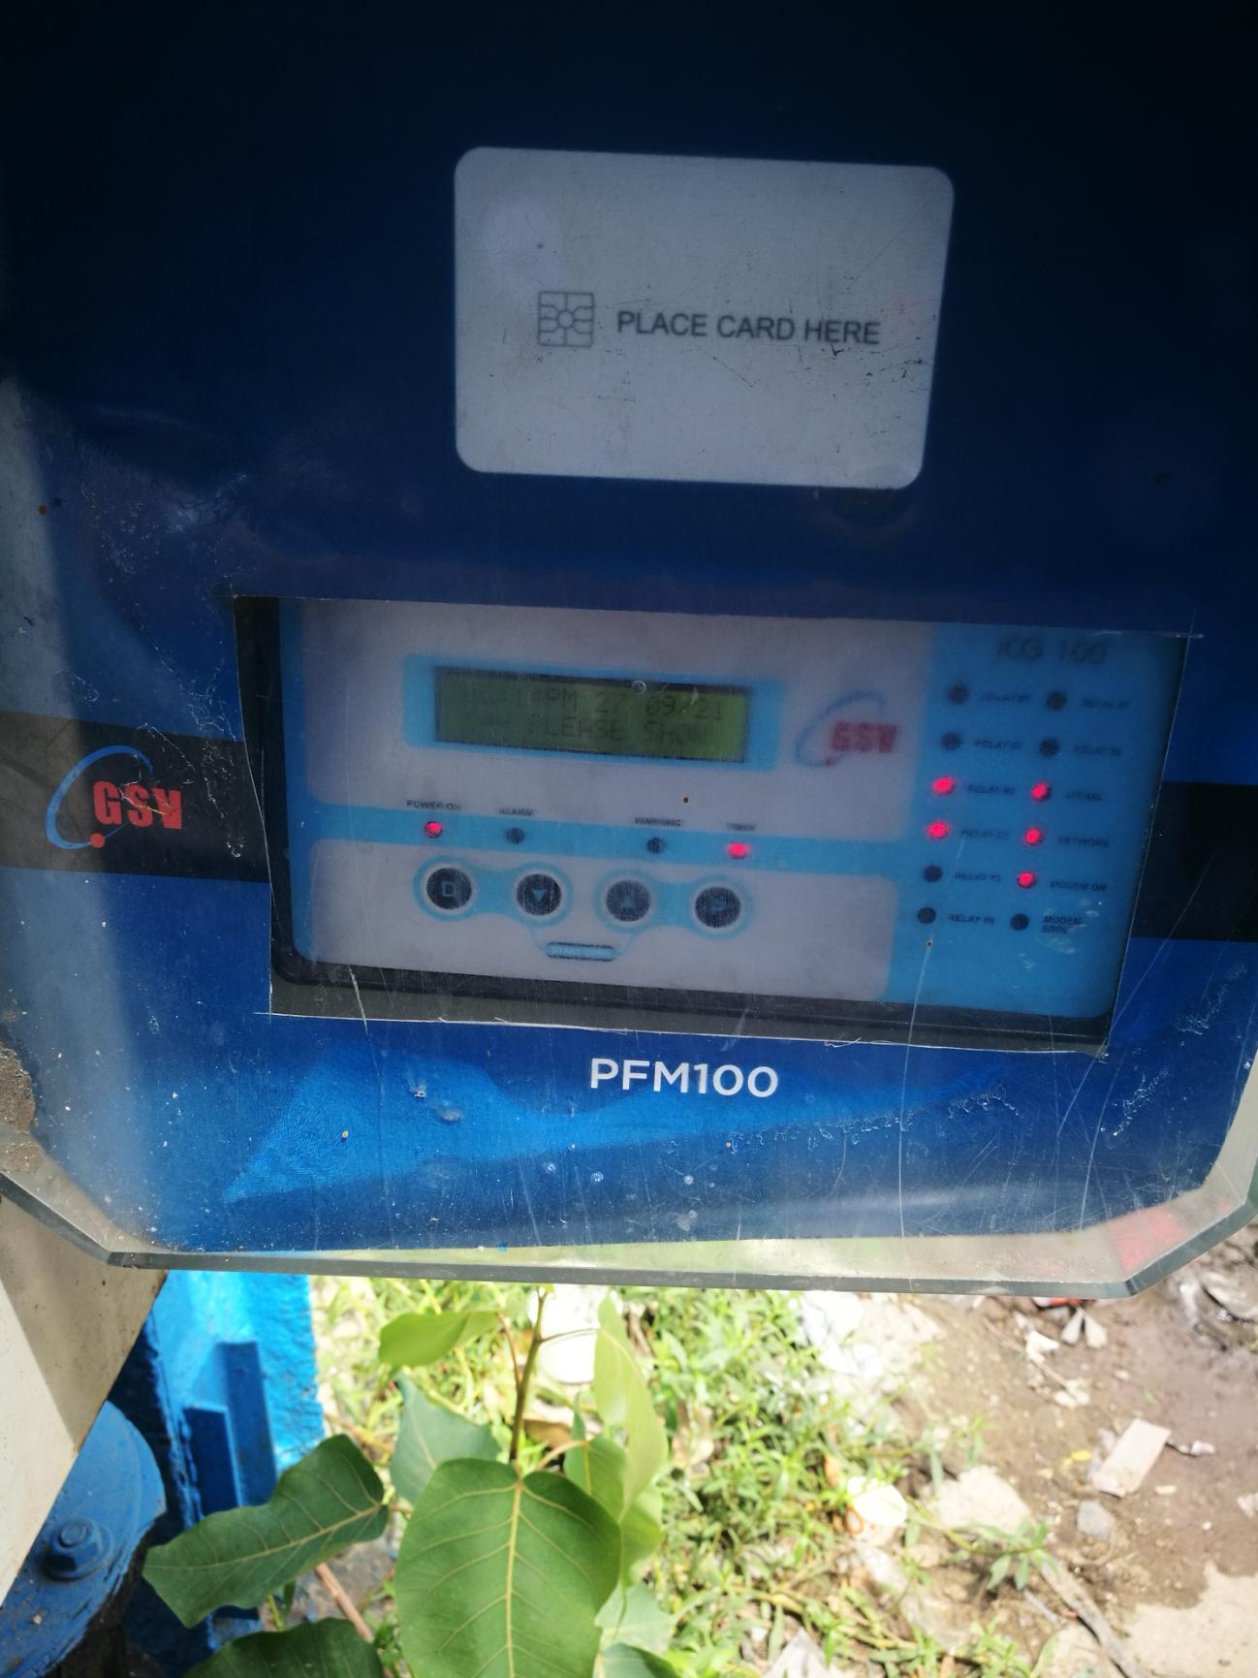

## Southern Headworks WDS

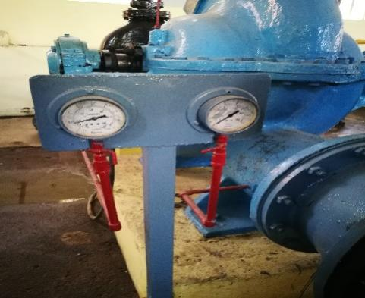 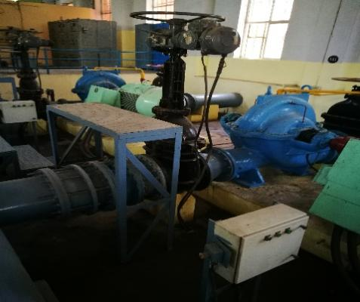 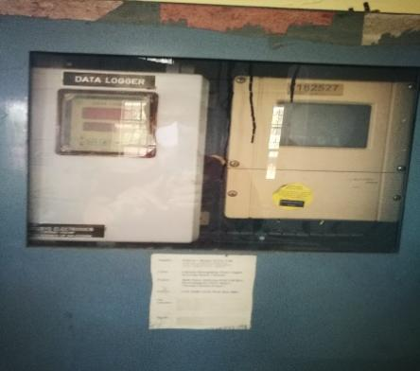

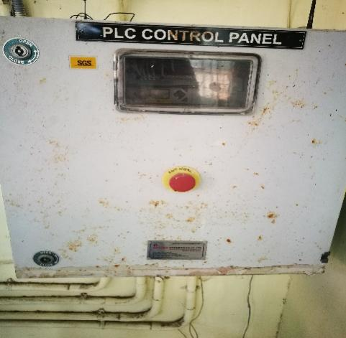 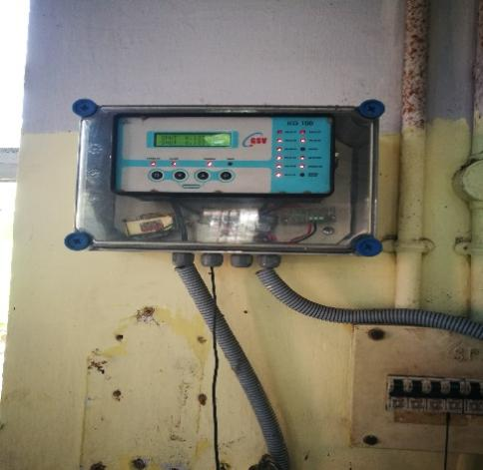 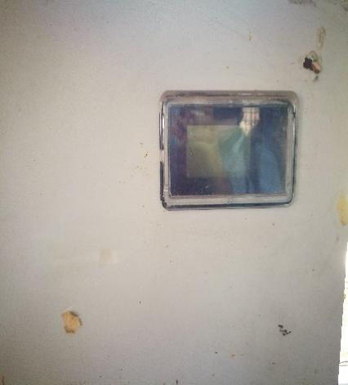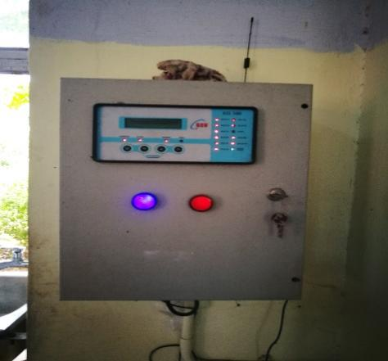 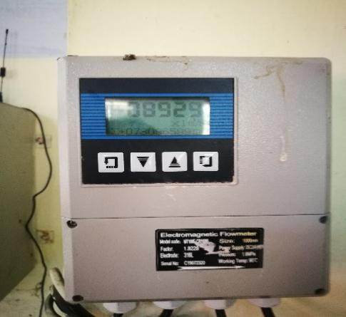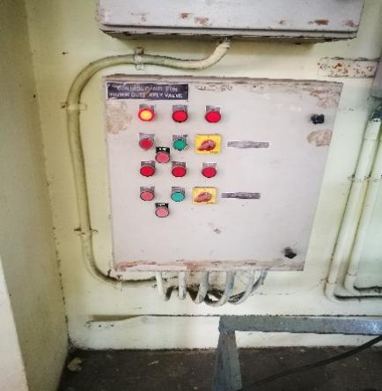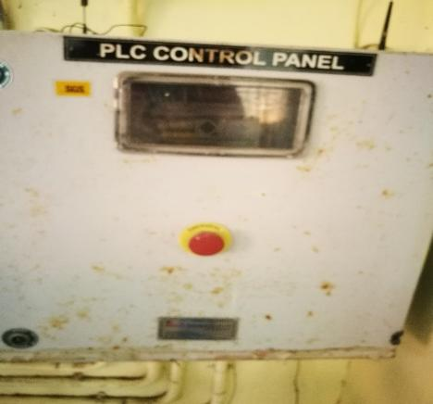 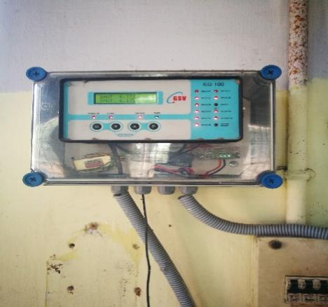 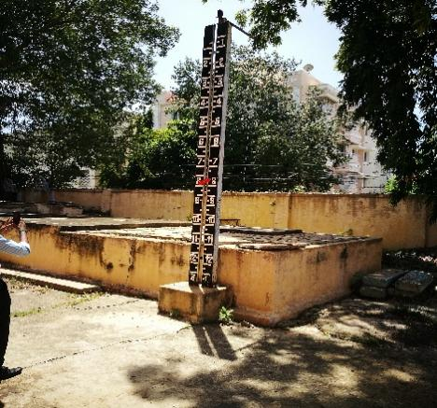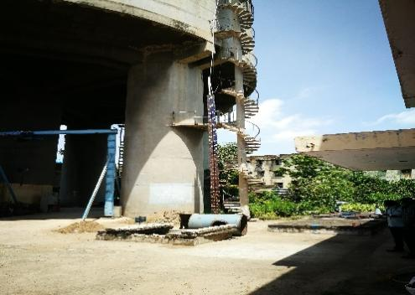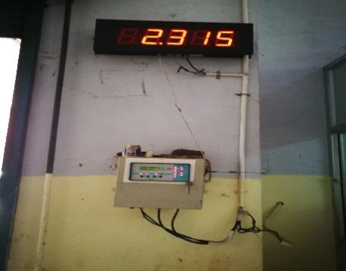 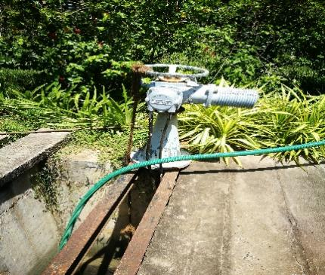

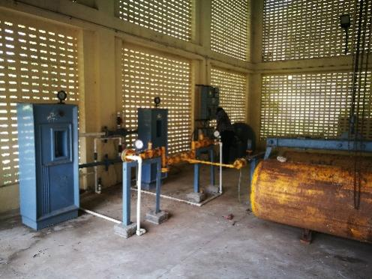 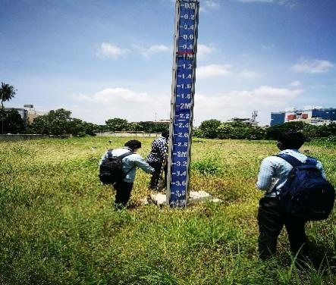 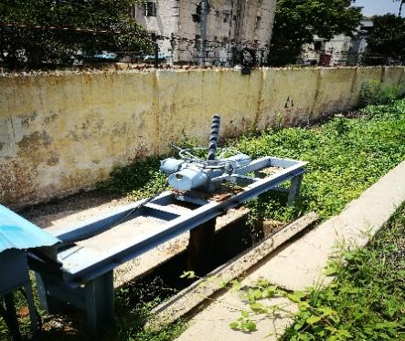

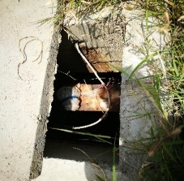

## Valluvarkottam WDS

